- $75 Entry Fee Handicap Singles
- 6 Games move 1 pair right after each game
- Cut to Top 6 Bracket Elimination Final
- #1 & #2 Seed Get First Round Bye
- 1 Game Match/ Stairstep Bracket Final
- Must have BATB Tournament Average to Bowl
- 12Gm BATB Ave / If under 12 Gms will use Highest 20/21 Book
- 40 pin Max Hcp for Men/ 60 pin Max Hcp for Ladies / Per Game
- Limited to first 60 Paid Entries!!!
10. Optional Scratch Singles / Brackets / High Game
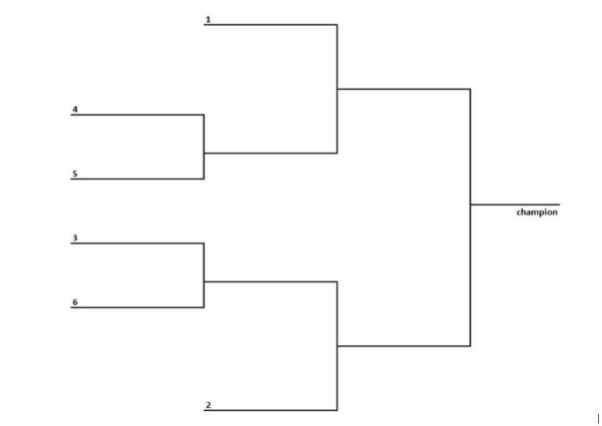
30 Entries | 40 Entries | 50 Entries | 60 Entries
$ 600.00 | $ 700.00 | $ 800.00 | $ 900.00
$ 300.00 | $ 350.00 | $ 400.00 | $ 450.00
$ 150.00 | $ 175.00 | $ 200.00 | $ 225.00
$ 150.00 | $ 175.00 | $ 200.00 | $ 225.00
$ 75.00 | $ 125.00 | $ 150.00 | $ 175.00
$ 75.00 | $ 125.00 | $ 150.00 | $ 175.00
 | $ 75.00 | $ 100.00 | $ 100.00
 | $ 75.00 | $ 100.00 | $ 100.00
 |  | $ 75.00 | $ 100.00
 |  | $ 75.00 | $ 100.00
 |  |  | $ 75.00
 |  |  | $ 75.00

